

ShippingInstructions

papiNet Standard - Version 2.31

Documentation

Global Standard for the Paper and Forest Products Supply Chain

Build V2R31_20121203
Date 2012-12-17

Production Build

Copyright
Copyright 2000 - 2012 papiNet G.I.E (“papiNet”) and International Digital Enterprise Alliance, Inc. (“IDEAlliance”) collectively “Copyright Owner”. All rights reserved by the Copyright Owner under the laws of the United States, Belgium, the European Economic Community, and all states, domestic and foreign. This document may be downloaded and copied provided that all copies retain and display the copyright and any other proprietary notices contained in this document. This document may not be sold, modified, edited, or taken out of context such that it creates a false or misleading statement or impression as to the purpose or use of the papiNet specification, which is an open standard. Use of this Standard, in accord with the foregoing limited permission, shall not create for the user any rights in or to the copyright, which rights are exclusively reserved to the Copyright Owner.
papiNet, IDEAlliance, and the members of all papiNet Groups (collectively and individually, "Presenters") make no representations or warranties, express or implied, including, but not limited to, warranties of merchantability, fitness for a particular purpose, title, or non-infringement. The presenters do not make any representation or warranty that the contents of this document are free from error, suitable for any purpose of any user, or that implementation of such contents will not infringe any third party patents, copyrights, trademarks or other rights. By making use of this document, the user assumes all risks and waives all claims against Presenters.
In no event shall Presenters be liable to user (or other person) for direct, indirect, special or consequential damages arising from or related to any use of this document, including, without limitation, lost profits, business interruption, loss of programs, or other data on your information handling system even if Presenters are expressly advised of the possibility of such damages.

Use of Documents in papiNet Implementations
Documents may be used as templates for a papiNet implementation. The Presenters grant the right to modify and edit them to fit an actual implementation project provided all copies display the copyright and any other proprietary notices contained in this document. Such modified documents must not be distributed beyond the trading partners implementing or maintaining a papiNet connection.

Table of Contents
Copyright 2
Use of Documents in papiNet Implementations 2
Table of Contents 3
ShippingInstructions Documentation 4
ShippingInstructions e-Document Overview 4
The Scope of ShippingInstructions e-Document 4
Business Rules for ShippingInstructions 4
Processing the ShippingInstructions e-Document 5
Understanding the Diagrams and Content 7
ShippingInstructions Root Element 9
ShippingInstructions 9
Primary Elements 12
ShippingInstructionsHeader 12
ByProduct 13
ShippingInstructionsLineItemByProduct 14
ByShipTo 16
ShippingInstructionsLineItemByShipTo 17
ShippingInstructionsSummary 19
Appendix 20
ShippingInstructions Scenario Listing 20
Scenario A 20
Scenario B 21
Scenario C 22
Scenario D 23
Scenario E 24
Scenario F 25

ShippingInstructions Documentation

ShippingInstructions e-Document Overview
The ShippingInstructions e-Document communicates delivery information for product(s) supported by a purchase order. After a buyer sends a seller a PurchaseOrder, the buyer may send shipping instructions when notified the goods are ready to ship by an InitialShipmentAdvice type of DeliveryMessage e-Document, or when the shipment details for the product are finalized.
The line item in the ShippingInstructions e-Document is either by Product, when one product is being sent to multiple locations, or by Ship To when multiple products are being sent to the same location. Each line item in the ShippingInstructions e-Document refers either to a product included in a PurchaseOrder or to a product contained in a line item of a purchase order.
The ShippingInstructions e-Document specifies delivery locations, schedule(s), and quantities for the product(s) in the PurchaseOrder. The schedule may define a specific date and/or time for delivery or include a time range (defined by date and/or time).
When the product(s) are actually shipped the seller would send a DeliveryMessage e-Document to the buyer.

The Scope of ShippingInstructions e-Document
The ShippingInstructions e-Document may include:
- Products and quantities to be delivered
- Requested delivery date and time
- Ship-to party
- Means of transport
- Carrier party

Business Rules for ShippingInstructions
The following tables list the business rules that apply to each CallOff e-Document type. There are no general rules that apply to both e-Document types. For the purposes of this discussion the term “ShippingInstructions line item” refers to either the ByProduct or ByShipTo elements.

General Business Rules
Identifier | Business Rule
SHIP001 | A ShippingInstructions e-Document has to have one or more ShippingInstructions line items.
SHIP002 | A ShippingInstructions e-Document has transport characteristics in a one-to-one relationship with the ShipToParty. See business rule SHIP006.
SHIP003 | A ShippingInstructions e-Document must specify one DeliverySchedule for each ShippingInstructions line item.
SHIP004 | The DeliverySchedule must specify at least one ShippingInstructions item quantity
SHIP005 | A ShippingInstructions line item must specify either a PurchaseOrderLineItem from an existing PurchaseOrder or specify a Product.
SHIP006 | [obsolete]
SHIP007 | A buyer can issue a ShippingInstructions cancellation to the seller.

Business Rules ShippingInstructions, MessageType = Confirmation
Identifier | Business Rule
SHIP008 | The ShippingInstructions Confirmation e-Document mirrors the ShippingInstructions e-Document—in other words:  - ShippingInstructions by Product is confirmed using the ShippingInstructions Product element.  - ShippingInstructions PurchaseOrderLineItem is confirmed using the ShippingInstructions PurchaseOrderLineItem.
SHIP009 | The ShippingInstructions – ShippingInstructions Confirmation messaging loop is closed by an e-Document containing a status of Accepted at the document, header, and line item levels.

Processing the ShippingInstructions e-Document
The buyer sends the first ShippingInstructions e-Document, which can then be accepted, amended, cancelled, or rejected by the seller via a shipping instructions confirmation. Subsequent ShippingInstructions e-Documents can be sent by the buyer with the seller responding using a shipping instructions confirmation. It is not mandatory to respond with a shipping instructions confirmation.
Notes:
- A buyer can include delivery schedule(s) for the product(s) either in a ShippingInstructions e-Document or in the purchase order itself.
- While a ShippingInstructions e-Document does not need to refer to a purchase order, a purchase order must exist for the seller to apply the delivery to. A ShippingInstructions e-Document cannot be used as a PurchaseOrder.
- When sending ShippingInstructions by product a purchase order must have been sent to the supplier prior to the ShippingInstructions e-Document as the supplier must have a purchase order in order to carry out the delivery.
e-Document processing depends on the e-Document type and on the values of status attributes at the e-Document, header, and line item levels. The status at the e-Document level determines the possible statuses at the header and line item levels.
The buyer has the option of including delivery schedule details in a purchase order or in the optional ShippingInstructions e-Document that follows. For the original ShippingInstructions e-Document from the buyer to the seller, the statuses at e-Document, header, and line item level are all set to “Original”.
The seller or seller representative then responds with a shipping instructions confirmation e-Document. If the seller accepts the shipping instructions and sets the status at all three levels to “Accepted”, that shipping instructions confirmation e-Document ends the shipping instructions exchange loop.
However, the seller may also send back a shipping instructions confirmation e-Document with a status of “Amended” because of an amendment at the line item level. Alternatively, the seller may reject the shipping instructions request as a whole or send back an e-Document with the status of “Accepted” but a line item that is either pending or rejected. In any of these cases, the shipping instructions confirmation e-Document would end with the buyer sends back a ShippingInstructions e-Document with the status of “Accepted” at every level.
The buyer can also resend a ShippingInstructions e-Document with the status of “Amended” or “Cancelled”. In this case, the shipping instructions exchange loop ends when the seller sends back a shipping instructions confirmation e-Document with the status of “Accepted” at all three levels.
If, when sending a ShippingInstructions e-Document, the buyer or seller wishes to communicate that nothing has changed in a portion of the e-Document then a ShippingInstructionsStatusType of “NoAction” may be used. The “NoAction” status is used to support the sending of the entire e-Document, for context, while communicating that certain aspects have not changed. The “NoAction” status is not available at the e-Document level (the root, level).

Status Values Used When Processing the ShippingInstructions e-Document
The status values that are used when processing the ShippingInstructions e-Document are:
- Original – Indicates that this is the first transmission of the CallOff e-Document.
- Accepted – Indicates that either the buyer or the seller has accepted the conditions in the previous e-Document in the loop. It is possible, however, for an individual line item to be rejected or pending in this situation.
- Amended – Indicates that the buyer wants to amend a previous ShippingInstructions e-Document or that either the buyer or seller is amending the conditions in the previous e-Document in the loop.
- Cancelled – Indicates that the buyer wants to cancel the ShippingInstructions e-Document.
- Rejected – Indicates that either the buyer or seller is rejecting the conditions in the previous e-Document in the loop.
If the status of the ShippingInstructionsStatusType attribute is “Original”, then the status in both the ShippingInstructionsHeaderStatusType and ShippingInstructionsLineItemStatusType attributes is also “Original”.
If the status in the ShippingInstructionsStatusType Field is “Accepted”, then the status in the ShippingInstructionsHeaderStatusType and ShippingInstructionsLineItemStatusType fields can be:
- “Accepted” – Indicates that the buyer or seller accepts either the header or line item.
- “Rejected” (only at the line item level) – Indicates that the buyer or seller rejects the conditions specified at the header or line item level.
If the status in the ShippingInstructionsStatusType attribute is “Amended”, then the status in the ShippingInstructionsHeaderStatusType and ShippingInstructionsLineItemStatusType fields can be:
- “Accepted” – Indicates that the buyer or seller accepts either the header or line item.
- “Amended” – Indicates that either the buyer or seller has changes to the header or line item.
- “Rejected” (only at the line item level) – Indicates that the buyer or seller rejects the conditions specified at the header or line item level.
- “NoAction” – Indicates that nothing has changed at either the header or line-item level.
If the status in the ShippingInstructionsStatusType attribute is “Cancelled”, then the status in both the ShippingInstructionsStatusType and ShippingInstructionsLineItemStatusType fields is “Cancelled”.
If the status in the ShippingInstructionsStatusType attribute is “Rejected”, then the status in both the ShippingInstructionsHeaderStatusType and ShippingInstructionsLineItemStatusType is “Rejected”.

Understanding the Diagrams and Content
This section provides an explantion of the graphical view and descriptive content associated with the schema structures.
- The graphics contain elements, attributes, content model indicators, cardinality indicators, and data type information.
- Associated with each graphic are the definitions for the parent item and any associated child items. All attributes are listed first, followed by the elements.
- Children are grouped together using, what is termed, a content model.
- Cardinality is communicated for each item.
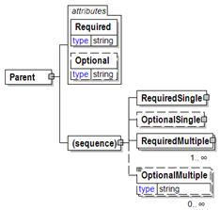
Let's use the following sample graphic as an explanatory vehicle. This graphic displays a parent element that has four elements and two attributes.

Elements:
Elements are displayed using a simple rectangle.
- A required element has a solid outline.
- An optional element has a dashed outline.
- Repeatability is shown via a multip-page outline along with an indication of the repeatability in the bottom right-hand side of the element.
- If the element permits the entry of textual content three-horizontal lines appear in the upper left-hand corner (See, "OptionalMultiple").
- The element's data-type is displayed below the element name. (In addition a default value, if it exists, can be shown.
- If the element contains further element or attribute content a gray box appears at the right-hand middle portion of the outline (See, "RequiredSingle", OptonalSingle", RequiredMultiple").

Attributes:
Attributes are contained within a tabbed container that is labelled "attributes".
- A required attribute has a solid outline.
- An optional attribute has a dashed outline.

Content model indicators:
There are three possible types of content: “sequence”, “choice”, and “all”. The sample above shows "sequence".
- (sequence)
The sequence of the items to the right of the graphic (or below the text) are grouped together.
- (choice)
A choice of the items to the right of the graphic (or below the text) is permitted.
- (all)
All the items to the right of the graphic are required.
Content models can also display cardinality aspects (single, multiple, optional, required), these are shown in a way similar to elements.

ShippingInstructions Root Element

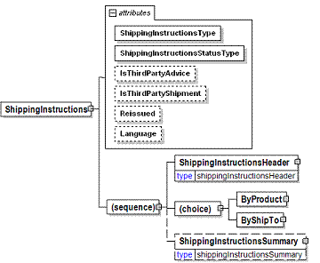
ShippingInstructions
The ShippingInstructions element is the root element for the ShippingInstructions e-Document.
The ShippingInstructions e-Document communicates delivery information for product(s) supported by a purchase order.
ShippingInstructionsType [attribute]
ShippingInstructionsType is mandatory. A single instance is required.
ShippingInstructionType defines the type of shipping instruction.
This item is restricted to the following list.
ShippingInstructionsConfirmation
Confirmation of the Shipping Instruction.
ShippingInstructionsDistribution
Shipping Instruction serves as a billable order for shipping product that was produced under a previous manufacturing order.
ShippingInstructionsPackaging
To be deprecated in a future version. Guidance will be given to trading partners not to use this enumeration.
ShippingInstructionsRouting
ShippingInstructions issued in conjunction with a PurchaseOrder for shipping the product.
ShippingInstructionsStatusType [attribute]
ShippingInstructionsStatusType is mandatory. A single instance is required.
ShippingInstructions Status Type
This item is restricted to the following list.
Accepted
The supplied information is accepted.
Amended
The supplied information is changed.
Cancelled
The supplied information is cancelled. Items that have been cancelled are not included in totals on the summary levels of the e-document.
Original
The supplied information is the first version of that information.
Rejected
The supplied information is rejected.
IsThirdPartyShipment [attribute]
Shipment request to a party other than the party that ordered the product from the supplier
IsThirdPartyShipment is optional. A single instance might exist.
This item is restricted to the following list.
Yes
No
IsThirdPartyAdvice
An advice to a third party of a ShippingInstructions.
IsThirdPartyAdvice is optional. A single instance might exist.
This item is restricted to the following list.
Yes
No
Reissued [attribute]
Reissued is optional. A single instance might exist.
Either "Yes" or "No". Default is “No”
This item is restricted to the following list.
Yes
No
Language [attribute]
Language is optional. A single instance might exist.
XML has embraced 2 and 3 digit language codes through the application of an addendum to the standard.
Information on the content of this attribute is available at: http://www.loc.gov/standards/iso639-2/ this is the official site of the ISO 639-2 Registration Authority.
- http://www.w3.org/International/O-HTML-tags.html provides an explanation of the errata updating XML.
- http://www.ietf.org/rfc/rfc3066.txt is the key document that is referenced in the above errata.
(sequence)
The sequence of items below is mandatory. A single instance is required.
ShippingInstructionsHeader
ShippingInstructionsHeader is mandatory. A single instance is required.
Information common to all items in a ShippingInstructions e-Document.
(choice)
[choice] is optional because of choice construct.
ByProduct
ByProduct is optional because of choice construct.
Identification takes place by product.
ByShipTo
ByShipTo is optional because of choice construct.
ByShipTo
ShippingInstructionsSummary
ShippingInstructionsSummary is optional. A single instance might exist.
Summary information for the ShippingInstructions e-Document.

Primary Elements

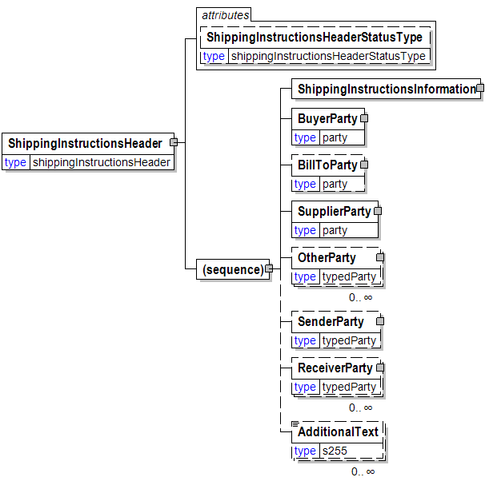
ShippingInstructionsHeader
Information common to all items in a ShippingInstructions e-Document.
ShippingInstructionsHeaderStatusType [attribute]
ShippingInstructionsHeaderStatusType is optional. A single instance might exist.
ShippingInstructions Header Status Type
This item is restricted to the following list.
Accepted
The supplied information is accepted.
Amended
The supplied information is changed.
NoAction
The supplied information has not been amended and thereby requires no action.
Original
The supplied information is the first version of that information.
Rejected
The supplied information is rejected.
(sequence)
The sequence of items below is mandatory. A single instance is required.
ShippingInstructionsInformation
ShippingInstructionsInformation is mandatory. A single instance is required.
A group item containing information unique to this ShippingInstructions and reference information used to identify the product to be shipped
BuyerParty
BuyerParty is mandatory. A single instance is required.
The legal entity to which the product is sold. Also commonly referred to as the sold-to party or customer. If no OtherParty is defined as the Payer, the Buyer is the Payer.
BillToParty
BillToParty is optional. A single instance might exist.
The address where the invoice is to be sent.
SupplierParty
SupplierParty is mandatory. A single instance is required.
The organisation or business entity responsible for providing the product. SupplierParty is also the seller of the product, if Seller is not specified as OtherParty = Seller.
OtherParty
OtherParty is optional. Multiple instances might exist.
An organisation or business entity other than those specifically detailed within a business document.
SenderParty
SenderParty is optional. A single instance might exist.
The business entity issuing the business document, the source of the document.
- The entity responsible for the content. If the sender party has out sourced the message service to a third party the SenderParty is the issuer of the e-document and not the party performing the transmission service of the electronic message.
ReceiverParty
ReceiverParty is optional. Multiple instances might exist.
The business entity for whom the business document is intended, the destination of the document.
- The entity interested in the content. If the receiver party has outsourced the message service to a third party the ReceiverParty is the intended party for the e-document and not the party performing the receiving service of the electronic message.
AdditionalText
AdditionalText is optional. Multiple instances might exist.
A text field that is used to communicate information not previously defined or for special instructions. To be used only for circumstances not covered by specific elements.

ByProduct
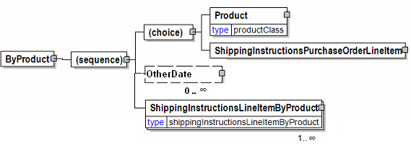Identification takes place by product.
(sequence)
The sequence of items below is mandatory. A single instance is required.
(choice)
[choice] is optional because of choice construct.
Product
Product is optional because of choice construct.
Product is a group item defining the article and its characteristics. Product is used to specify product characteristics organized by ProductIdentifier, ProductDescription, and Classification. Book Manufacturing, Label Stock, Paper, Pulp, Recovered Paper, Wood Products, and Virgin Fibre market segments have defined their product characteristics and conversion features for implementation in papiNet.
ShippingInstructionsPurchaseOrderLineItem
ShippingInstructionsPurchaseOrderLineItem is optional because of choice construct.
Purchase order line item information for purchase order being referenced in ShippingInstructions.
OtherDate
OtherDate is optional. More than one instance can occur.
A date that may not be specifically detailed within a document (example: print date at the PurchaseOrderLineItem).
ShippingInstructionsLineItemByProduct
ShippingInstructionsLineItemByProduct is mandatory. One instance is required, multiple instances might exist.
ShippingInstructionsLineItemByProduct

ShippingInstructionsLineItemByProduct
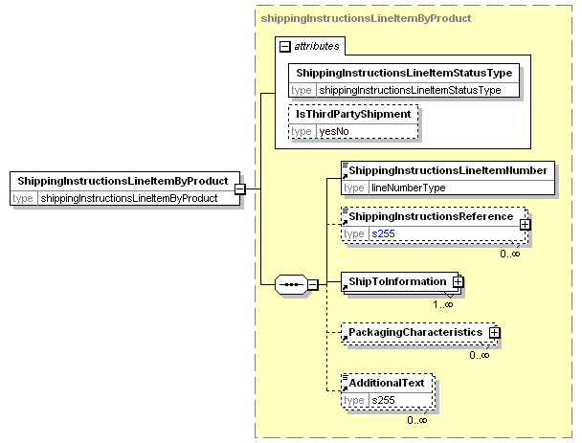
ShippingInstructionsLineItemByProduct
ShippingInstructionsLineItemStatusType [attribute]
ShippingInstructionsLineItemStatusType is mandatory. A single instance is required.
ShippingInstructions Line Item Status Type
This item is restricted to the following list.
Accepted
The supplied information is accepted.
Amended
The supplied information is changed.
Cancelled
The supplied information has been cancelled. Items that have been cancelled are not included in totals on the summary levels of the e-document.
NoAction
The supplied information has not been amended and thereby requires no action.
Original
The supplied information is the first version of that information.
Pending
The supplied information is not complete and will be updated later.
Rejected
The supplied information is rejected.
IsThirdPartyShipment [attribute]
IsThirdPartyAdvice is optional. A single instance might exist.
Shipment request to a party other than the party that ordered the product from the supplier.
This item is restricted to the following list.
Yes
No
(sequence)
The sequence of items below is mandatory. A single instance is required.
ShippingInstructionsLineItemNumber
ShippingInstructionsLineItemNumber is mandatory. A single instance is required.
The sequential number that uniquely identifies the ShippingInstructions line item.
ShippingInstructionsReference
ShippingInstructionsReference is optional. Multiple instances might exist.
A group item detailing relevant references (such as ISBN) pertaining to the ShippingInstructions and/or product being shipped.
ShipToInformation
ShipToInformation is mandatory. One instance is required, multiple instances might exist.
Group element containing information about the ship to and delivery of a product.
PackagingCharacteristics
PackagingCharacteristics is optional. Multiple instances might exist.
An element containing carton or pallet packing information. PackagingCharacteristics can either have the BoxCharacteristics or PalletPackagingCharacteristics element not both.
AdditionalText
AdditionalText is optional. Multiple instances might exist.
A text field that is used to communicate information not previously defined or for special instructions. To be used only for circumstances not covered by specific elements.

ByShipTo
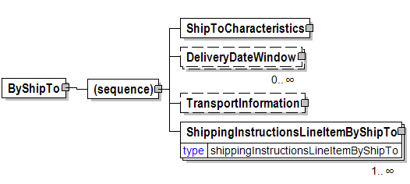
ByShipTo
(sequence)
The sequence of items below is mandatory. A single instance is required.
ShipToCharacteristics
ShipToCharacteristics is mandatory. A single instance is required.
A group item that provides information important for the Ship-To Party.
A group item that provides information important for the Ship-To Party.ShipToCharacteristics may be referenced at both the header and line item level. The reference at the header is required and acts as a default for the value at the line level, unless overridden at the line level.
DeliveryDateWindow
DeliveryDateWindow is optional. Multiple instances might exist.
A group item defining the date/time interval for delivery to take place. An element which may contain the estimated date for which delivery is expected. This date is not absolute.
TransportInformation
TransportInformation is optional. A single instance might exist.
A grouping element for transport information.
ShippingInstructionsLineItemByShipTo
ShippingInstructionsLineItemByShipTo is mandatory. One instance is required, multiple instances might exist.
ShippingInstructions Line Item By Ship To

ShippingInstructionsLineItemByShipTo
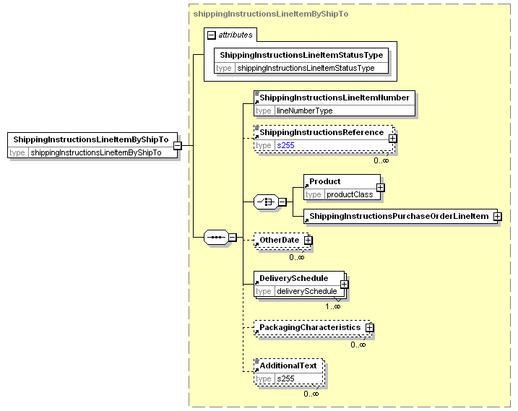
ShippingInstructions Line Item By Ship To
ShippingInstructionsLineItemStatusType [attribute]
ShippingInstructionsLineItemStatusType is mandatory. A single instance is required.
ShippingInstructions Line Item Status Type
This item is restricted to the following list.
Accepted
The supplied information is accepted.
Amended
The supplied information is changed.
Cancelled
The supplied information has been cancelled. Items that have been cancelled are not included in totals on the summary levels of the e-document.
NoAction
The supplied information has not been amended and thereby requires no action.
Original
The supplied information is the first version of that information.
Pending
The supplied information is not complete and will be updated later.
Rejected
The supplied information is rejected.
(sequence)
The sequence of items below is mandatory. A single instance is required.
ShippingInstructionsLineItemNumber
ShippingInstructionsLineItemNumber is mandatory. A single instance is required.
The sequential number that uniquely identifies the ShippingInstructions line item.
ShippingInstructionsReference
ShippingInstructionsReference is optional. Multiple instances might exist.
A group item detailing relevant references (such as ISBN) pertaining to the ShippingInstructions and/or product being shipped.
(choice)
[choice] is optional because of choice construct.
Product
Product is optional because of choice construct.
Product is a group item defining the article and its characteristics. Product is used to specify product characteristics organized by ProductIdentifier, ProductDescription, and Classification. Book Manufacturing, Label Stock, Paper, Pulp, Recovered Paper, Wood Products, and Virgin Fibre market segments have defined their product characteristics and conversion features for implementation in papiNet.
ShippingInstructionsPurchaseOrderLineItem
ShippingInstructionsPurchaseOrderLineItem is optional because of choice construct.
Purchase order line item information for purchase order being referenced in ShippingInstructions.
OtherDate
OtherDate is optional. Multiple instances might exist
A date that may not be specifically detailed within a document (example: print date at the PurchaseOrderLineItem).
DeliverySchedule
DeliverySchedule is mandatory. One instance is required, Multiple instances might exist.
A group item defining a series of DeliveryDateWindow(s) in which specified quantities must be delivered.
PackagingCharacteristics
PackagingCharacteristics is optional. Multiple instances might exist.
An element containing carton or pallet packing information. PackagingCharacteristics can either have the BoxCharacteristics or PalletPackagingCharacteristics element not both.
AdditionalText
AdditionalText is optional. Multiple instances might exist.
A text field that is used to communicate information not previously defined or for special instructions. To be used only for circumstances not covered by specific elements.

ShippingInstructionsSummary
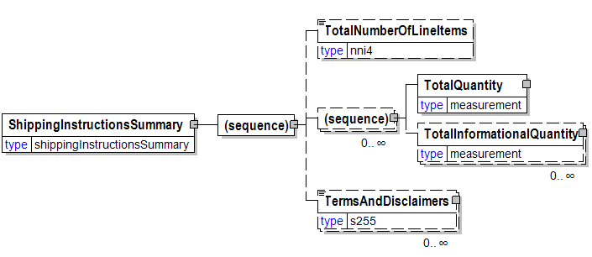
Summary information for the ShippingInstructions e-Document.
(sequence)
The sequence of items below is mandatory. A single instance is required.
TotalNumberOfLineItems
TotalNumberOfLineItems is optional. A single instance might exist.
The total number of individual line items in the document, regardless of the status or type.
(sequence)
The sequence of items below is optional. Multiple instances might exist.
TotalQuantity
TotalQuantity is mandatory. A single instance is required.
The total quantity of similar items in the business document. TotalQuantity is primarily used in the summary section of documents where it is repeatable to permit totaling for different units of measure.
TotalInformationalQuantity
TotalInformationalQuantity is optional. Multiple instances might exist.
A quantity that is used to communicate related information about the parent element. This element represents a total that is derived from individual line items.
TermsAndDisclaimers
TermsAndDisclaimers is optional. Multiple instances might exist.
An element that contains legal information with an indication of what the Language is.

Appendix

ShippingInstructions Scenario Listing
Scenario A | Original ShippingInstructions from Buyer, accepted by Supplier
Scenario B | Original ShippingInstructions from Buyer, amended by Supplier, amendments accepted by Buyer.
Scenario C | Original ShippingInstructions from Buyer, ShippingInstructions line item rejected by Supplier, rejection accepted by Buyer.
Scenario D | Original ShippingInstructions from Buyer, pending status returned by Supplier, accepted status subsequently sent by Supplier.
Scenario E | Amendment to a ShippingInstructions Header details sent by Buyer, Amendment accepted by Supplier.
Scenario F | Amendment to a ShippingInstructions by Buyer, Supplier amends Buyer’s amendment, which is accepted by the Buyer.

Scenario A
e-Document | ShippingInstructions
Scenario | Original ShippingInstructions from Buyer, accepted by Supplier
Outcome | ShippingInstructions is entered into the Supplier’s system
Initiator | Buyer
Receiver | Supplier
Preconditions | This Use Case assumes the Buyer has previously sent a PurchaseOrder to the Supplier and the Supplier has already Accepted the order.
Trigger | None
Step 1. | Buyer sends an original ShippingInstructions to the Supplier  Statuses sent within the e-Document:  - ShippingInstructionsStatusType = “Original”  - ShippingInstructionsHeaderStatusType = “Original”  - ShippingInstructionsLineItemStatusType = “Original”
Step 2. | Supplier responds with a ShippingInstructionsConfirmation.  Statuses sent within the e-Document:  - ShippingInstructionsStatusType = “Accepted”  - ShippingInstructionsHeaderStatusType = “Accepted”  - ShippingInstructionsLineItemStatusType = “Accepted”

Scenario B
e-Document | ShippingInstructions
Scenario | Original ShippingInstructions from Buyer, amended by Supplier, amendments accepted by Buyer
Outcome | ShippingInstructions is entered into the Supplier’s system. Buyer’s system is updated to reflect Supplier changes.
Initiator | Buyer
Receiver | Supplier
Preconditions | This Use Case assumes the Buyer has previously sent a PurchaseOrder to the Supplier and the Supplier has already Accepted the order.
XML File | The name of any sample file.
Trigger | None
Step 1. | Buyer sends an original ShippingInstructions to the Supplier  Statuses sent within the e-Document:  - ShippingInstructionsStatusType = “Original”  - ShippingInstructionsHeaderStatusType = “Original”  - ShippingInstructionsLineItemStatusType = “Original”
Step 2. | Supplier responds with a ShippingInstructionsConfirmation with amended line item(s).  Statuses sent within the e-Document:  - ShippingInstructionsStatusType = “Amended”  - ShippingInstructionsHeaderStatusType = “Accepted”  - ShippingInstructionsLineItemStatusType = “Amended”
Step 3. | Buyer responds with a ShippingInstructions, accepting the amended line item(s).  Statuses sent within the e-Document:  - ShippingInstructionsStatusType = “Accepted”  - ShippingInstructionsHeaderStatusType = “Accepted”  - ShippingInstructionsLineItemStatusType = “Accepted”

Scenario C
e-Document | ShippingInstructions
Scenario | Original ShippingInstructions from Buyer, Shipping¬Instructions rejected by Supplier, rejection accepted by Buyer.
Outcome | ShippingInstructions line item(s) is rejected (not entered) by the Supplier’s system. Buyer’s system is updated to reflect rejected line item(s).
Initiator | Customer
Receiver | Supplier
Preconditions | This Use Case assumes the Buyer has previously sent a PurchaseOrder to the Supplier and the Supplier has already Accepted the order.
Trigger | None
Step 1. | Buyer sends an original ShippingInstructions to the Supplier  Statuses sent within the e-Document:  - ShippingInstructionsStatusType = “Original”  - ShippingInstructionsHeaderStatusType = “Original”  - ShippingInstructionsLineItemStatusType = “Original”
Step 2. | Supplier responds with a ShippingInstructionsConfirmation with Rejected line item(s).  Statuses sent within the e-Document:  - ShippingInstructionsStatusType = “Amended”  - ShippingInstructionsHeaderStatusType = “Accepted”  - ShippingInstructionsLineItemStatusType = “Rejected”
Step 3. | Buyer responds with a ShippingInstructions, accepting the rejected line item(s).  Statuses sent within the e-Document:  - ShippingInstructionsStatusType = Accepted  - ShippingInstructionsHeaderStatusType = “Accepted”  - ShippingInstructionsLineItemStatusType = “Accepted”

Scenario D
e-Document | ShippingInstructions
Scenario | Original ShippingInstructions from Buyer, pending status returned by Supplier, accepted status sent by Supplier.
Outcome | ShippingInstructions is entered into the Supplier’s system.
Initiator | Buyer
Receiver | Supplier
Preconditions | This Use Case assumes the Buyer has previously sent a PurchaseOrder to the Supplier and the Supplier has already Accepted the order.
Trigger | None
Step 1. | Buyer sends an original ShippingInstructions to the Supplier  Statuses sent within the e-Document:  - ShippingInstructionsStatusType = “Original”  - ShippingInstructionsHeaderStatusType = “Original”  - ShippingInstructionsLineItemStatusType = “Original”
Step 2. | Supplier responds with a ShippingInstructionsConfirmation with one or more line item(s) pending confirmation.  Statuses sent within the e-Document:  - ShippingInstructionsStatusType = “Amended”  - ShippingInstructionsHeaderStatusType = “Accepted”  - ShippingInstructionsLineItemStatusType = “Pending”
Step 3 | Supplier later responds with a ShippingInstructionsConfirmation, accepting the pending line item(s).  Statuses sent within the e-Document:  - ShippingInstructionsStatusType = “Accepted”  - ShippingInstructionsHeaderStatusType = “Accepted”  - ShippingInstructionsLineItemStatusType = “Accepted”

Scenario E
e-Document | ShippingInstructions
Scenario | Amendment to a ShippingInstructions Header details sent by Customer, Amendment accepted by Supplier.
Outcome | ShippingInstructions amendments are entered into the Supplier’s system.
Initiator | Buyer
Receiver | Supplier
Preconditions | This Use Case assumes :  - The Buyer has previously sent a PurchaseOrder to the Supplier and the Supplier has already accepted the order.  - The Customer has previously sent a ShippingInstructions to the Supplier
Trigger | Customer amends ShippingInstructions Header details
Step 1. | Buyer sends a ShippingInstructions to the Supplier with amended Header details  Statuses sent within the e-Document:  - ShippingInstructionsStatusType = “Amended”  - ShippingInstructionsHeaderStatusType = “Amended”  - ShippingInstructionsLineItemStatusType = “Accepted”
Step 2. | Supplier responds with a ShippingInstructionsConfirmation with Accepted Header.  Statuses sent within the e-Document:  - ShippingInstructionsStatusType = “Accepted”  - ShippingInstructionsHeaderStatusType = “Accepted”  - ShippingInstructionsLineItemStatusType = “Accepted”

Scenario F
e-Document | ShippingInstructions
Scenario | Amendment to a ShippingInstructions by Buyer, Supplier amends Customers amendment, which is accepted by the Customer
Outcome | Amended ShippingInstructions is entered into the Supplier’s system.
Initiator | Buyer
Receiver | Supplier
Preconditions | This Use Case assumes:  - The Buyer has previously sent a PurchaseOrder to the Supplier and the Supplier has already accepted the order.  - The Buyer has previously sent a ShippingInstructions to the Supplier
Trigger | Buyer amends ShippingInstructions Header details
Step 1. | Buyer sends a ShippingInstructions to the Supplier with amended Header details  Statuses sent within the e-Document:  - ShippingInstructionsStatusType = “Amended”  - ShippingInstructionsHeaderStatusType = “Amended”  - ShippingInstructionsLineItemStatusType = “Accepted”
Step 2. | Supplier responds with a ShippingInstructionsConfirmation with further amendments to the Header details  Statuses sent within the e-Document:  - ShippingInstructionsStatusType = “Amended”  - ShippingInstructionsHeaderStatusType = “Amended”  - ShippingInstructionsLineItemStatusType = “Accepted”
Step 3. | Buyer responds with a ShippingInstructions, accepting the amended header details.  Statuses sent within the e-Document:  - ShippingInstructionsStatusType = “Accepted”  - ShippingInstructionsHeaderStatusType = “Accepted”  - ShippingInstructionsLineItemStatusType = “Accepted”

